A sleepover with Molly

by

Gráinne Dillion

Hi I’m Grainne and today I’m writing about a sleepover my best friend and I had during Summer
My morning
First, I woke up in my brand new sheets that I had bought yesterday in Penneys. It was a very wet and miserable day in Inagh. Once I had got dressed, I went to eat breakfast. After breakfast I got dressed and cleaned my room. My room was already very clean so that didn’t take me long. I made my bed and organized my wardrobe. Molly was coming at two o’clock by then it was already half eleven. Next I fed my hamster Spike and played with him for a while.
Afternoon
By the time I finished playing with Spike, it was time to get dressed. After that I went outside with my brother Martin. We played a bit of hurling and we climbed some bales but while we were on the bales martin accidently fell off of one of them. I made sure he was ok then we went back inside.
Day
When we came in, I decided to draw for a while so I drew a little cow in a field. Suddenly, I heard a knock at the door I was so excited IT WAS MOLLY!I invited her in and we went to my room. She was staying for the night. I showed her Spike and she loved him she asked if we could play with him so I said sure. I showed her our special trick and she was in awe. Next, we drew on my walls with wall markers. It was quite unique as such I had never drew on my walls before I felt like a little artist. Soon after that my mom called us to go to Lees road.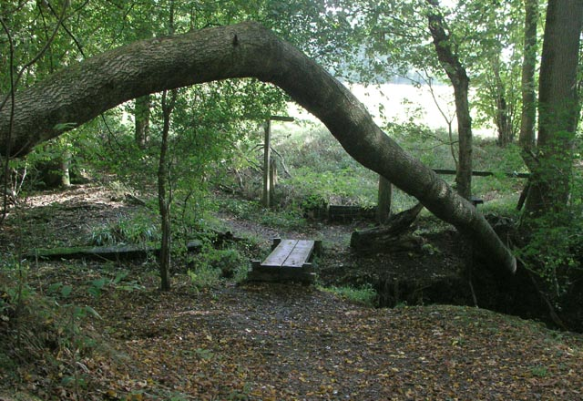 By then the weather had cleared up and it was sunny out. I packed up our bikes and of we went in the car. Once we got to Lees road my mom said we can cycle the long path while she walked to short path we immediately shooed off on our bikes. It was amazing. We cleared the path in no time. Mom wasn’t finished yet so we decided to wait for her. While we were waiting we decided to go to the nearby skate park for bikes, skateboards and skateboards.

Evening
Once we got home we had some delicious pasta for dinner. After dinner we went outside to play on the swings. Unfortunately, I fell off the swing and Molly made sure I was ok and we went back inside and watched some YouTube.
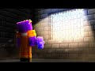 After that we agreed to play on some screens. We ended up playing the best most brilliant game ever Street Fighter 3. It was quite an old game but that still didn’t forget the fact that it was the greatest game ever and Molly liked it too. At 3:am we were both starving so I decided to make some late-night pancakes with mom of course. After that we were so tired that we fell asleep talking about how the holidays were too short and they needed to be longer.
The next morning
The next morning, we woke up at 12 o’clock which was a bit late but it was the summer holidays so that wasn’t a problem. We got dressed and had breakfast. It was a horrible wet, damp, traitorously rainy day. After our brilliant brain storm on what to do, we drew. I drew the White House and Molly drew her own house. Next, we went on a walk to the nearby forest. I knew this forest like it was my home but we still brought Lilly along
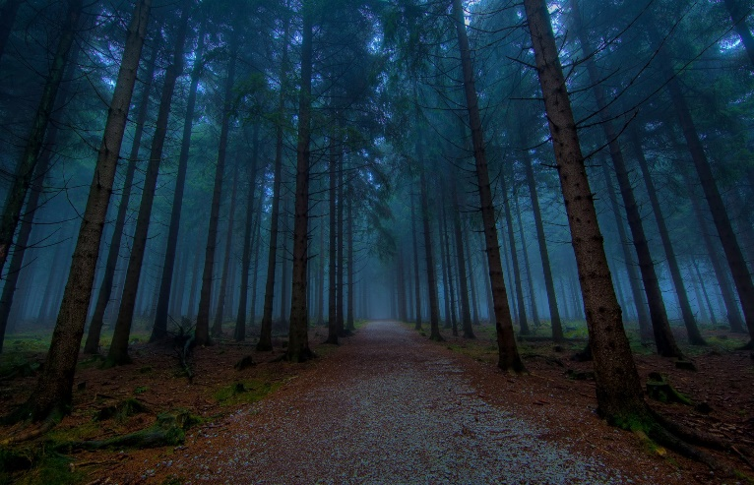
Suddenly, out of the corner of my eye, I saw a little glimmer of blue light. I went to investigate and lone behold it was only my speaker that I had been looking for days!
A note from Molly:
Hi, I am Molly and Grainne wants me to write for a bit so. I think Grainne didn’t tell ye about all the food dye she put in the pancakes at 3.00AM IN THE MORNING!!!!!!!Did she tell ye that she also brought loombands out at 2.30AM and started making bracelets that’s quite enough from Molly Bye nice meeting ye!
Alrighty I’m back and that’s where we are now aren’t we kidney bean (that’s what I call Molly) YEP! We were on quite the adventure earlier. We went on a walk and we got lost in a forest until we heard my dog Lilly barking behind us. We turned and there she was standing behind us. We were surprised when Lilly started walking as if to say this way! After our little adventure into the unknown…we had dinner. During dinner Molly wanted to have a water fight, so invited some of our other friends over and had a MASIVE WATER FIGHT! I was exhausted afterward and so was Molly after that really fun water fight we watched some more YouTube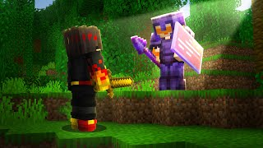
We were so tired that we eventually went to sleep.

In the morning I was a bit sad because we had to drop Molly off. We said our goodbyes and poof Molly was gone. Bye for now folks!

